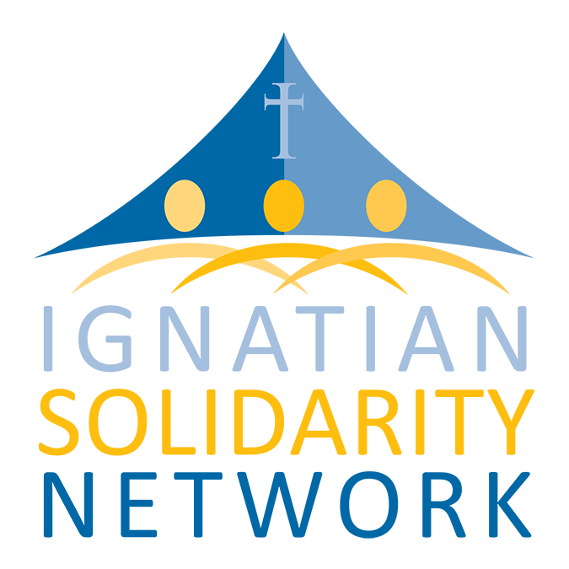

PURPOSE OF THE VISIT: Ask Congress to pass comprehensive immigration reform

WHAT OUR FAITH TELLS US:

Catholic Social Teaching tells us that it is our “duty to welcome the foreigner out of charity and respect for the dignity and rights of the human person” (Source: U.S. Conference of Catholic Bishops). As members of the Ignatian Solidarity Network, we stand with the U.S. Catholic Bishops and the U.S. Jesuit Provincials in asking for immigration reform that supports family unity and a pathway to citizenship.

WHAT WE SEE:

- Personal Testimony (if applicable): Personalize the issue by sharing your story or the story of someone directly affected by our nation’s broken immigration system, who may be a family member, classmate, or friend.

- Families and Communities Torn Apart: Our faith recognizes family as the cornerstone of our communities, but hundreds of thousands of families are separated by our broken immigration system. Backlogs at USCIS of up to 22 years and the insufficient number of family-based visas force family members to choose between being separated for extended periods of time or illegally entering the country (Source: Bread for the World).

- Talent Wasted: Catholic Social Teaching directly states that all people have a right and duty to participate in society for the common good, and we must provide avenues for participation in the U.S. Approximately 1.8 million individuals currently residing in the United States were brought to the U.S. at a young age. Each year, approximately 65,000 undocumented students graduate from American high schools. Many hope to pursue higher education, join the military, or enter the workforce, but their lack of legal status places those dreams in jeopardy and exposes them to deportation (Source: Immigration Policy Center).

- Workers Exploited: Much of our U.S. economy requires migrant labor that is often inconsistent with the Catholic Social Teaching principle of the dignity of work. Migrant workers are consistently exploited and forced to work in unsafe conditions without fair compensation; this continues to drive down wages and promote divisions in communities and workplaces (Source: Southern Poverty Law Center).

- Suffering Ignored: We must treat all people with dignity and respect, and our asylum and refugee system is under threat. Rather than offering protection and compassion for those who have been forced to flee from their countries of origin, our system treats them as potential terrorists, and subjects them to lengthy delays in having their cases decided. (Source: Jesuit Refugee Service/USA).

- An Increasingly Militarized Border: Catholic Social Teaching calls us to the promotion of peace and disarmament, which includes respect and cooperation between nations in addition to the absence of war. The misguided border militarization of the last decade has cost $100 billion, doubled the size of the Border Patrol without sufficient screening, training or accountability, led to over 6,000 dead and murdered immigrants, and allowed widespread civil and human rights violations. (Source: Kino Border Initiative).

COMPREHENSIVE IMMIGRATION REFORM:

Protects the Vulnerable:
- 16.6 million people are in “mixed-status” families—those with at least one member who is undocumented. Nine million of these families have at least one U.S.-born child (Source: Pew Research Hispanic Center).
- Creating a pathway to citizenship for undocumented immigrants helps keep families together, and prevents children from needlessly being placed in foster care (Source: Applied Research Center).
- Refugees, asylum–seekers, and stateless people will face a fairer, more efficient system that respects human dignity (Source: Jesuit Refugee Service/USA).

Allows Immigrant Youth to Realize the American Dream:
- The passage of the DREAM Act would grant many undocumented youth access to legal residency, work authorization, and eventual citizenship. This bill would provide a status that matches the American identity they already have and an opportunity for them to fully contribute to the U.S. economy and their communities (Source: U.S. Jesuit Conference).

Reduces Future Undocumented Immigration:
- The only way to reduce undocumented immigration is to fix our immigration system so that people seeking work and family reunification can enter legally. For undocumented immigrants who are already here, we must provide a realistic way for them to adjust their status by passing background checks, learning English, and paying taxes if they aren’t already, while working toward citizenship. Our faith teaches us that people have a right to migrate— this is not amnesty. It is the only smart, practical, faithful way to deal with the approximately 11 million undocumented immigrants in the U.S.

Creates Safe and Humane Borders:
- Professionalized, accountable and humane enforcement of immigration laws should be part of any comprehensive immigration reform package. This will involve providing more robust and transparent oversight of all agencies responsible for enforcement measures (USCIS, CBP, and ICE) and a change in detention and deportation practices to preserve immigrants’ dignity and safety. These changes should include eliminating nighttime deportations, keeping families together during the deportation process, and allowing NGOs to access Customs and Border Patrol facilities (Source: Kino Border Initiative).

Improves the Economy:
- As legalization and naturalization of undocumented immigrants bolsters their wages, helps bring families out of poverty, and increases tax revenue, it will strengthen our economy and reduce our budget deficit.

OUR REQUESTS:

Will the Congressperson publically support and vote for a bill that includes the following principles?
- Create an accessible pathway to citizenship for all 11 million people without documentation;
- Support young people without documentation by enacting the DREAM Act;
- Work to maintain family unity in all elements of the immigration system;
- Protect the most vulnerable, especially refugees & asylum seekers;
- Respect the rights of U.S. and immigrant workers;
- Ensure the human rights of immigrant families....as our immigration laws are enforced.

